Webpersonals 2.0
Engineering Capacity Study Results

Version 1.1

Prepared by:

Jim Munro
Medhat Roshdi
George Howitt
Jack Veiga

Webpersonals 2.0
Engineering Capacity Study Results
Table of Contents

1. Purpose 4
2. Methodology 4
2.1 vmstat 4
2.1.1 CPU 5
2.1.2 Swap Used 5
2.1.3 Blocks per Second 5
2.2 sp_sysmon 6
2.2.1 CPU Percent 6
2.2.2 I/O Requests 6
2.2.3 Committed Transactions 6
2.2.4 Rows Modified 7
3. Architecture Overview 7
4. Network 8
4.1 Key Indicators 8
4.2 Results 8
4.3 Recommendations 9
5. Firewalls 9
5.1 Key Indicators 10
5.2 Results 10
5.3 Recommendations 11
6. Web Servers 12
6.1 Key Indicators 12
6.2 Results 12
6.3 Recommendations 14
7. Database Servers 15
7.1 Key Indicators 15
7.2 Results 15
7.2.1 Webdb1p 15
7.2.2 Webdb2p 17
7.2.3 Webdb3p 19
7.2.4 Webdb4p 21
7.2.5 Webdb5p 23
7.3 Recommendations 25
8. SSL Server 26
8.1 Key Indicators 26
8.2 Results 26
8.3 Recommendations 28
9. Image Server 28
9.1 Key Indicators 28
9.2 Results 28
9.3 Recommendations 30
10. Real Audio Server 31
10.1 Key Indicators 31
10.2 Results 31
10.3 Recommendations 32
11. Summary 33

Purpose

The purpose of the Webpersonals 2.0 Engineering Capacity Study was to determine the physical limitations of the current Web platform.

The key components analyzed by this study were network, firewalls, web servers, database servers and multi-media servers (audio and picture).

Monitoring of these components is an ongoing process and will need to be reviewed as new functionality is added to the application. This particular study concentrated on estimating the maximum volume of traffic that the key components can handle before performance becomes unacceptable.

This information will assist Marketing when planning and negotiating new deals. Analysis of this data will also give the Web Platform X team valuable information when planning architectural changes.

Methodology

Each selected component was monitored over time. Most of the data was acquired during the period of November 4, 2000 and December 4, 2000.

Activity monitored on each component included memory usage, cpu utilization, disk i/o and network bandwidth. This data was then correlated against the number of active users at the time of the sample.

Each of the indicators was then graphed to determine its utilization in relation to a variable number of users. In general, once a resource attains 100% utilization, performance is significantly reduced. Therefore this study will conclude that a component is at capacity when one of its indicators reaches 100% utilization.

Statistical data was collected from the databases using the Sybase sp_sysmon system monitoring utility which captures database statistics over a 5 minute period every hour. All other data was collected using the Linux vmstat utility which captures data at 5 second intervals throughout the day.

2.1 vmstat

vmstat is a Unix/Linux utility which displays system utilization information. This includes CPU, Memory and I/O. In general, this utility is very useful for displaying performance information for a machine. This study used vmstat to track performance for most of the Webpersonals components and in particular focused on cpu, swap used and disk i/o information.

For this study, vmstat data was collected from all machines (other than the Database Servers) at 5 second intervals for a period of one month.

2.1.1 CPU

After examining all of the indicators, we came to the conclusion that the major bottleneck facing Webpersonals components would be CPU.

All of the graphs shown on this report display CPU usage as a percentage. As user load is increased on a component, the amount of CPU required to service user requests also increases. The total amount of CPU power that a machine has to service requests is 100%.

A regression line was created using the sample data and extended to 100% in order to estimate the total number of concurrent users that can be supported before system performance begins to degrade.

2.1.2 Swap Used

The vmstat utility has many indicators pertaining to system memory usage. Linux constantly monitors the requirements of running applications and allocates memory to different areas as efficiently as possible. Because of this behavior, the amount of free memory displayed by the utility can be misleading.

As Linux begins to run out of available memory to satisfy running applications, it will begin to make greater use of ‘virtual memory’ by swapping the least recently used memory in and out of disk. As the amount of swap used by the operating system increases, performance can be reduced significantly due to the fact that disk speed is at least 10 times slower than RAM.

In general, we found that swap usage across components was at an acceptable level and did not increase significantly with the load indicated by our sample data.

2.1.3 Blocks per Second

vmstat displays disk i/o information in terms of ‘average number of blocks per second’. A Linux block is equivalent to 1K of data. Therefore ‘100 blocks per second’ means that an average of 100K of data per second was written to or read from physical disk during the sample period.

In general, we found that disk i/o across components was at an acceptable level and did not increase significantly with the load indicated by our sample data.

2.2 sp_sysmon

vmstat is not a good indicator of system utilization on a machine dedicated to running Sybase. One of the main reasons behind this is that Sybase will use up system CPU cycles whether or not it needs it to ensure that they are not allocated to other processes.

This study decided to use the Sybase utility ‘sp_sysmon’ in order to monitor system performance on the Database Servers.

Sp_sysmon data was collected from all 5 Database Servers for a period of 5 minutes, once an hour.

2.2.1 CPU Percent

This study concluded that CPU would be the major bottleneck across the database servers.

As with the vmstat graphs, all of the database server graphs shown on this report display CPU usage as a percentage. The total amount of CPU power that a machine has to service the database engine is 100%.

2.2.2 I/O Requests

The ‘i/o requests’ graphs contained in this report display the total number of disk read and write requests made by the Database Server during the 5 minute sample period. In general, 1 i/o request represents 2K of data read from or written to disk.

In general, we found that disk i/o requests across database servers increased in relation to the number of online users. However, it did not increase significantly with the load indicated by our sample data.

2.2.3 Committed Transactions

Both the graphs of ‘Committed Transactions’ and ‘Rows Modified’ give an indication of the amount of data being modified on a Sybase Database Server.

In database terms a Transaction describes a unit of work. This could involve the modification of one or more rows of data. For example, an average Accounting transaction involves a Credit to one or more accounts and a Debit to one or more accounts. Once all of the affected rows in a Transaction have been successfully modified, the Transaction is committed to disk.

The ‘Committed Transaction’ graphs displayed in this report indicate the total number of transactions that were successfully completed during the 5 minute sample period.

2.2.4 Rows Modified

The ‘Rows Modified’ graphs displayed in this report indicate the total number of rows that were inserted, updated or deleted in the database server during the 5 minute sample period.

In general, the total number of rows modified during a period should be greater than the total number of transactions committed during the same period.

Architecture Overview

The Web infrastructure is displayed in the following figure. The primary components are the Network, the Firewalls, the Web Servers, and the database servers. Additional components include the multi-media servers (Image Server and Real Audio Server) and the Secure server (SSL Server).

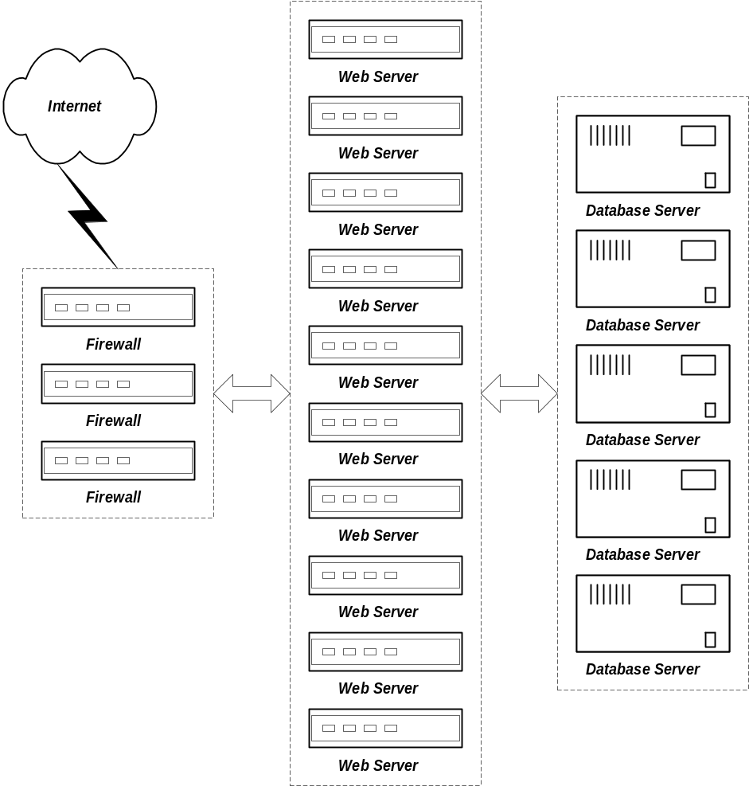

Network

Webpersonals currently communicates to the internet through a single Internet Service Provider (UUNET) which is located at 151 Front Street. Maximum throughput at UUNET is currently 100 Megabits.

Access to Front Street from the iMG Web Site at 10-4 Seasons Place is accomplished by an AT&T link. This link is currently configured at 35 Megabits. iMG is currently in the process of upgrading this link to 45 Megabits in anticipation of additional network traffic due to new Marketing initiatives. This link can be configured up to 100 Megabits.

Due to the fact that all traffic must go through the AT&T link, the maximum bandwidth available to Webpersonals users is currently 35 Megabits.

The Webpersonals site is currently peaking at 20Megabits.

4.1 Key Indicators

iMG monitors bandwidth usage on an ongoing basis. We have found that there is a linear correlation between the amount of bandwidth used and the number of users on the system.

Data collected from the iMG routers was correlated against online users in order to determine this relationship.

When the amount of users on the system exceeds the available bandwidth, performance will begin to decrease for all online users.

4.2 Results

By extending the bandwidth vs users line, we have concluded that the current network can support approximately 10,000 concurrent users before the available bandwidth of 35 Megabits is exhausted.

Once the AT&T link has been extended to 45 Megabits, the network will be able to support approximately 13,000 concurrent users.

When the AT&T link has been opened up to its maximum bandwidth of 100 Megabits, the network will be capable of supporting approximately 30,000 concurrent users. Any additional bandwidth will require a revised network architecture.

The following graph displays the correlation between network bandwidth and concurrent users.

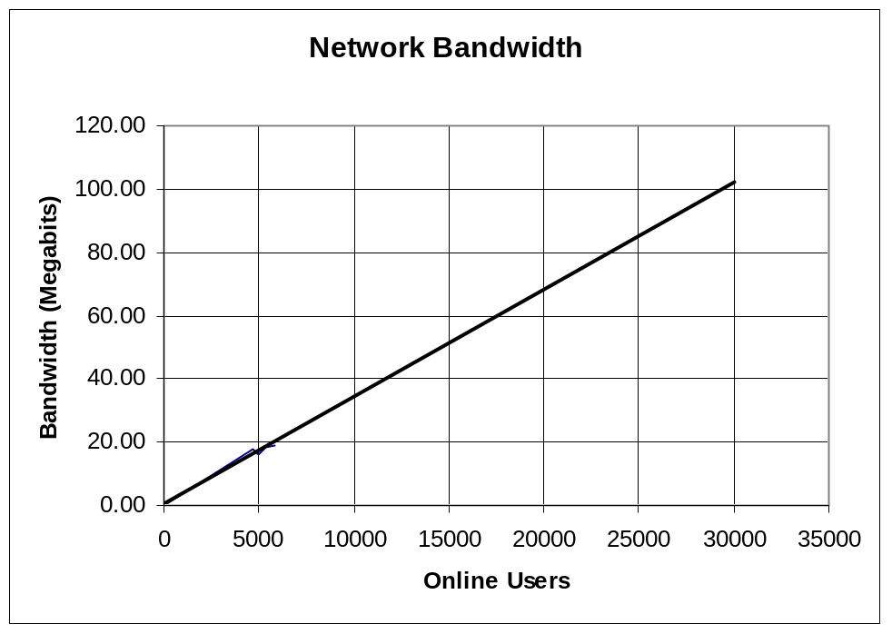

4.3 Recommendations

Changes to the AT&T link configuration require 4 to 6 weeks of lead time by AT&T. Bandwidth usage should be continuously monitored and a process should be put in place which uses this data and information about upcoming Marketing initiatives to ensure that a balance is maintained between telco costs and bandwidth availability.

We are currently in the process of extending the AT&T link to 45 Megabits.

Firewalls

Webpersonals uses 3 firewalls to direct internet traffic to the web servers. Traffic is distributed evenly to these firewalls by our ISP (UUNET).

Each firewall uses a Squid process to distribute user requests evenly to each of the 10 web servers. Squid is a caching proxy server that provides load balancing session redirection to the Web Servers.

Hardware configuration for the Firewalls is as follows:

- Each runs Linux (kernel version 2.2.13), with ipchains
- Squid version is 2.2
- Two of the firewalls are dual 450Mhz PIII, the third is a dual Xeon 550Mhz
- Each has a DPT raid controller with mirrored drives

5.1 Key Indicators

Since traffic is balanced evenly between firewalls, this study concentrated on one firewall ‘Squid1’ with the assumption that statistics across firewalls are consistent.

This study focused on vmstat information for CPU usage, Swap Used and Blocks per second of i/o.

5.2 Results

We found a spike of CPU usage and disk i/o during the period when 1000 to 2000 concurrent users were accessing the system. Further investigation found that this was due to the 5:00am ‘log rotate’ process. The log rotate process occurs once a day. During this procedure logs greater than 1 week old are truncated and the previous day’s logs are processed and copied to the webmonitor server for reporting.

We found that CPU utilization on the firewall rose as the number of users increased. A regression line on this data shows that our current firewall architecture can support a maximum of approximately 20,000 users before performance will begin to degrade.

Further analysis showed that the amount of Swap space used remained relatively constant which indicates that there is enough RAM available to satisfy user requests. Disk i/o was also very low.

The following 3 graphs show the results of the 3 indicators for the firewall ‘Squid1’.

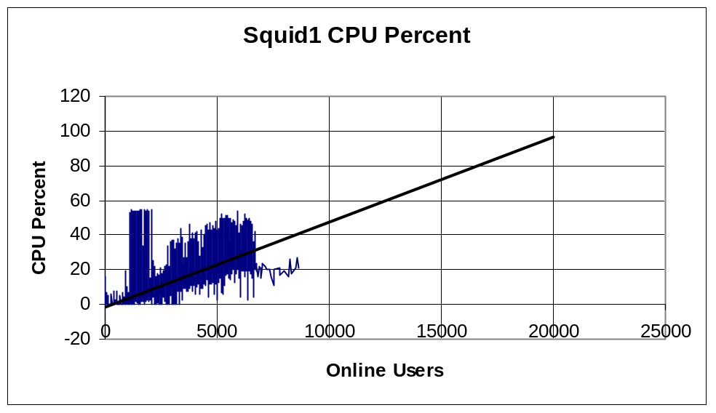

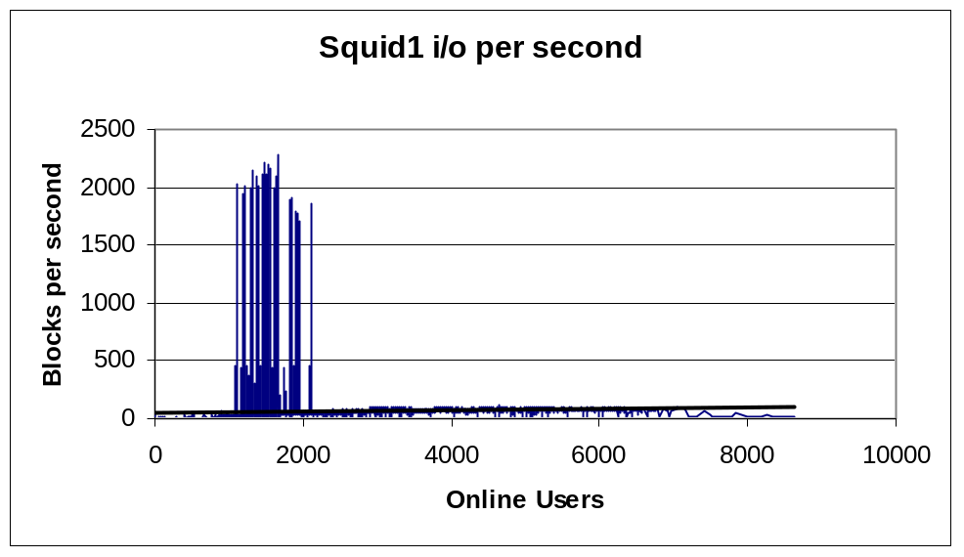

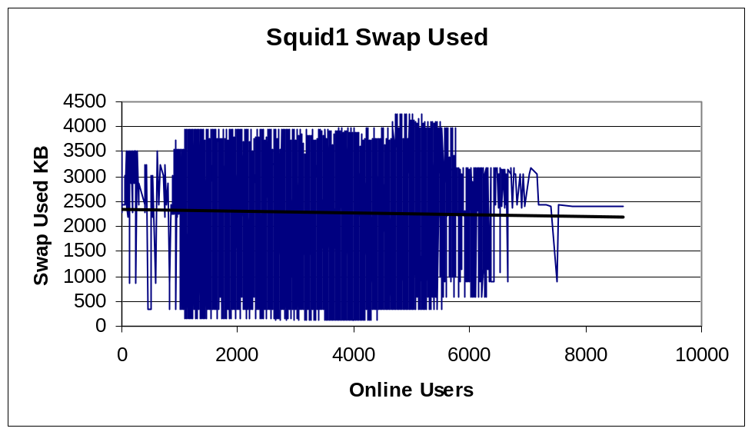

5.3 Recommendations

Monitoring of the firewalls should be an ongoing process.

An additional firewall should be acquired when CPU peaks at 75% or approximately 15,000 concurrent users.

Web Servers

Webpersonals uses 10 Apache Web Servers to service user requests. Requests are distributed evenly to the Web Servers via the Firewall Squid processes.

Hardware configuration for each Web Server is as follows:

- Each web server is a dual 700Mhz PIII, with 512Mb ram and 9Gb Disk.
- The operating system is Linux.
- Apache version is 1.3.12
- The vast majority of the content served by the web servers is dynamically generated.
- Approximately 23% of all traffic is image data, the rest is HTML
- The application code base is approximately 100,000 lines of Perl.
- 118 Million pages were served during December of 2000
- Over 300,000 pages are served per hour during peak times.

6.1 Key Indicators

User requests are distributed evenly across all 10 web servers. Therefore this study focused on a single web server (websrvr-100) with the assumption that statistics would be consistent across servers.

This study focused on vmstat information for CPU usage, Swap Used and Blocks per second of i/o.

6.2 Results

We found a spike of CPU usage and disk i/o during the period when 1000 to 2000 concurrent users were accessing the system. Further investigation found that this was due to the 5:00am ‘log rotate’ process. The log rotate process occurs once a day. During this procedure logs greater than 1 week old are truncated and the previous day’s logs are processed and copied to the webmonitor server for reporting.

We found that CPU utilization on the web servers rose as the number of users increased. A regression line on this data shows that our current Web Server architecture can support a maximum of approximately 16,000 users before performance will begin to degrade. This relates to roughly 1,600 users per Web Server.

Further analysis showed that the amount of Swap space used remained relatively constant which indicates that there is enough RAM available to satisfy user requests. Disk i/o was also very low.

The following 3 graphs show the results of the 3 indicators for the Web Server ‘websrvr-100’.

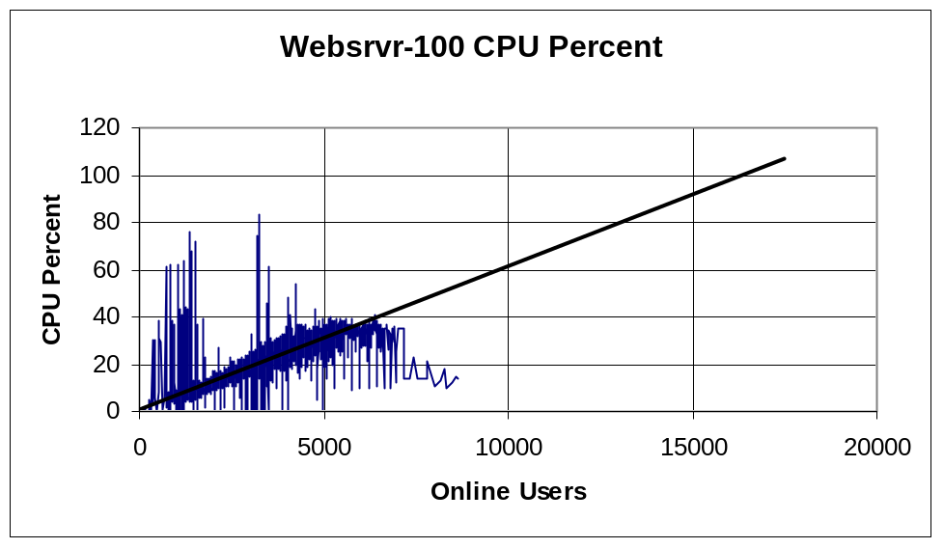

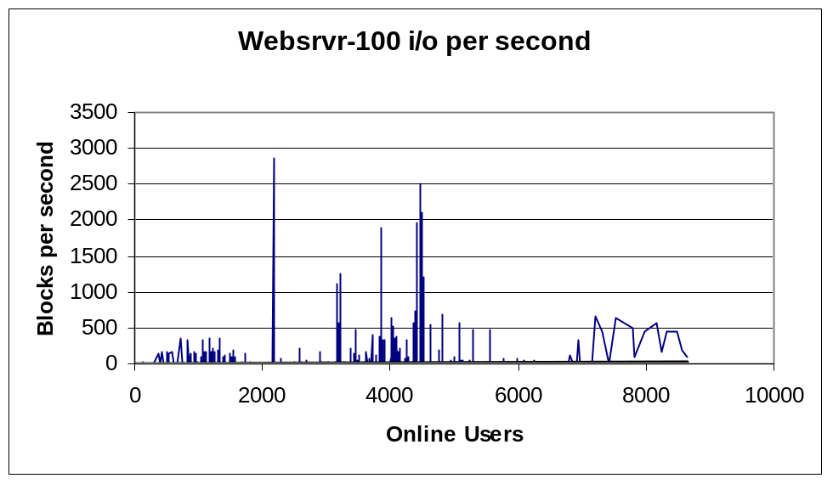

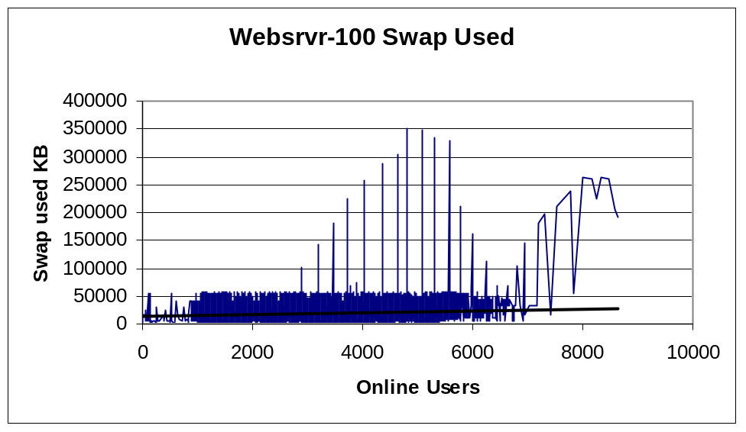

6.3 Recommendations

Monitoring of the Web Servers should be an ongoing process.

Additional Web Servers should be acquired when CPU levels peak at 75% or approximately 12,000 concurrent users.

Database Servers

Webpersonals services online users with five database servers. A sixth is used for offline reporting and statistics. Each runs a dedicated Sybase data server.

Hardware configuration for each database server is as follows:

- Each server is a quad Xeon 550Mhz, with 2Gb ram.
- Each has 72Gb of disk on a Mylex controller in a 0+1 configuration.
- Each server runs Linux.
- Sybase version is 11.9.2.
- The data model consists of approximately 280 entities distributed across the servers in logical groupings.

Data is split between the 5 database servers in the following manner:

Server | Data
Webdb1p | Administration, account management, associate maintenance
Webdb2p | User session management
Webdb3p | Instant messaging
Webdb4p | Manline/Womanline user information
Webdb5p | Heterosexual user information

7.1 Key Indicators

The Sybase utility ‘sp_sysmon’ was used to track CPU usage, i/o requests, committed transactions and rows modified for 5 minute sample periods once an hour.

7.2 Results

We found that the amount of system load compared to the number of online users varies from server to server. Webdb3p which services instant message requests and the administration server, webdb1p, have the highest load.

We also found some spikes between 1000 and 2000 users. Investigation showed that these were due to early morning batch processes which generate e-mail, daily statistics, etc.

The following graphs depict the results of our samples for each Database Server.

7.2.1 Webdb1p

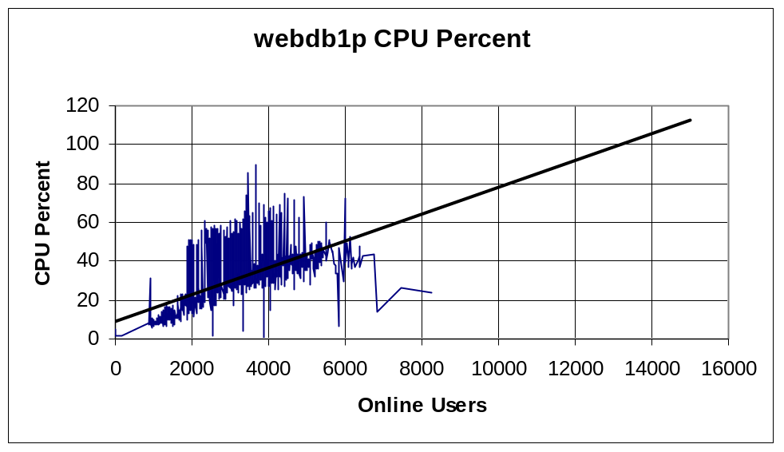

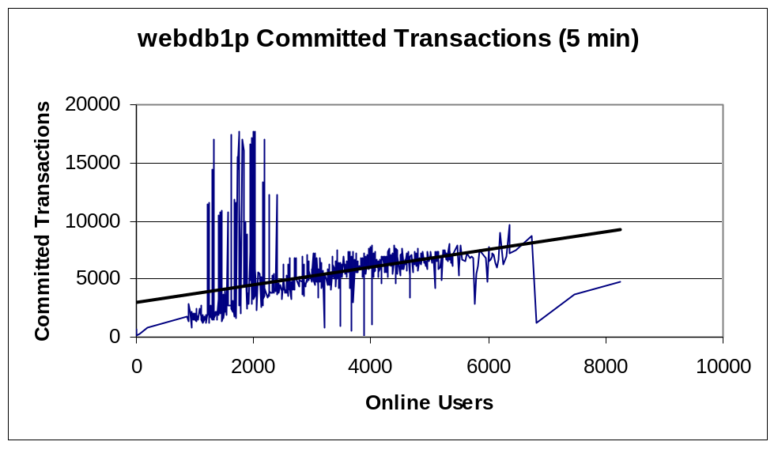

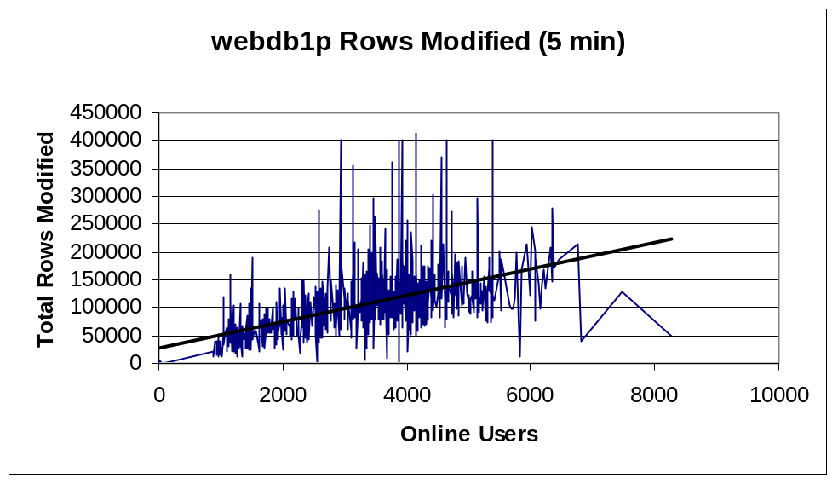

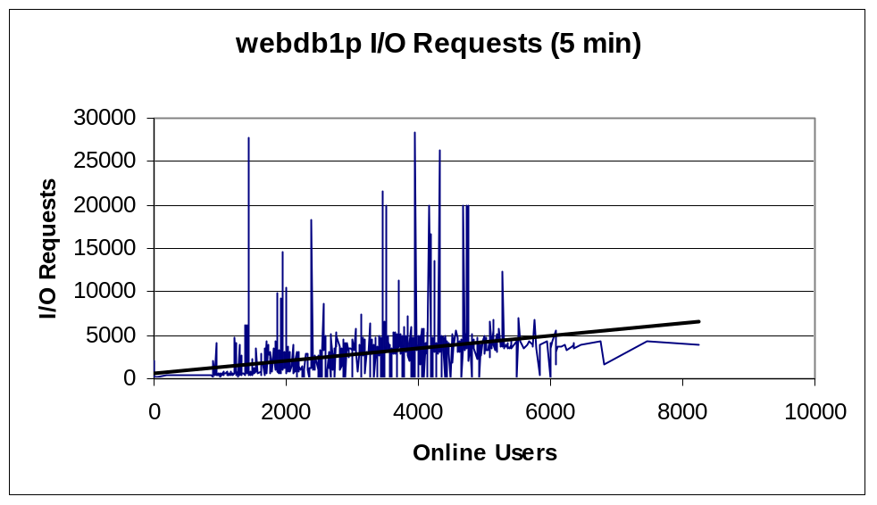

7.2.2 Webdb2p

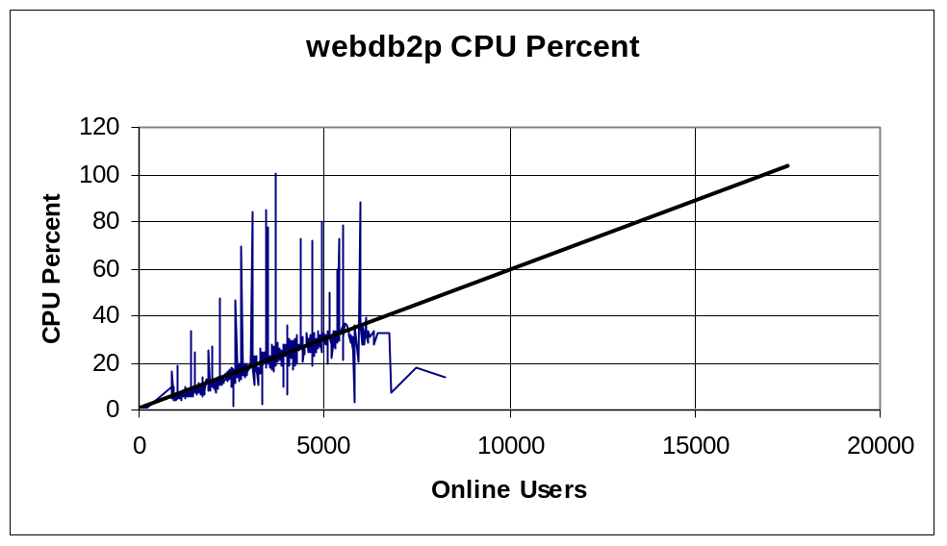

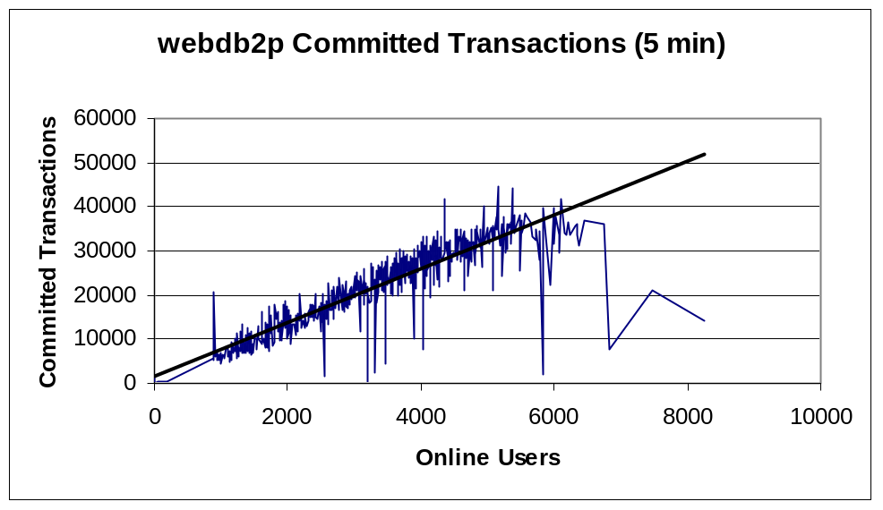

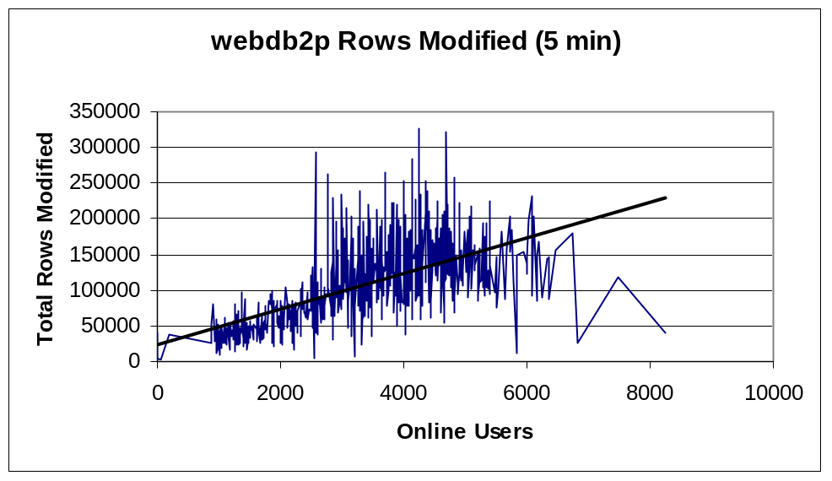

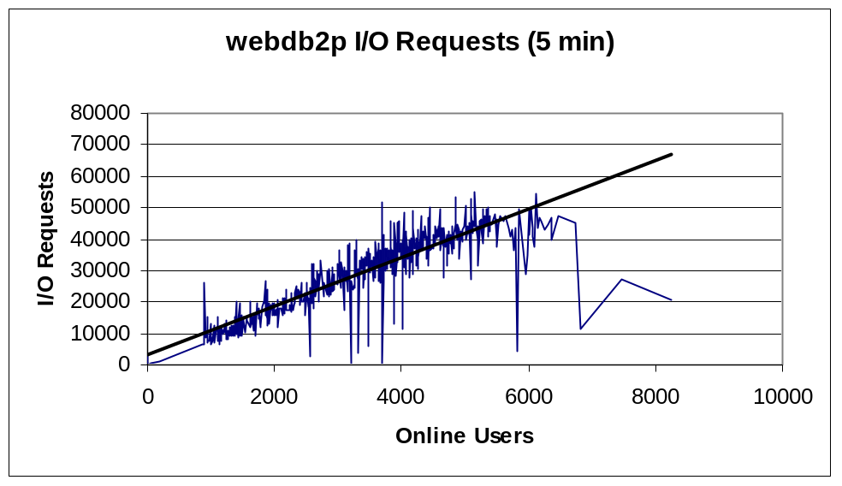

7.2.3 Webdb3p

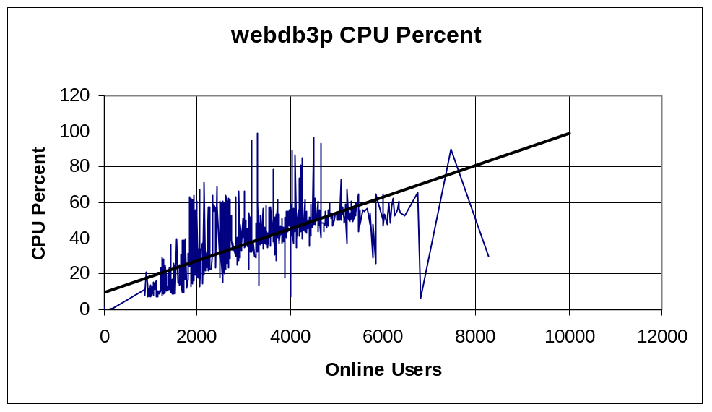

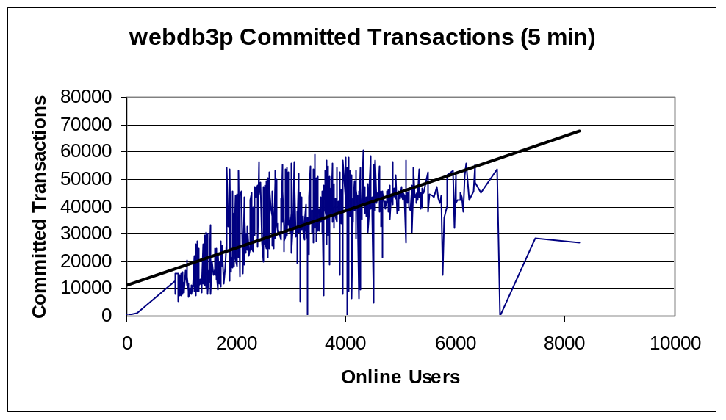

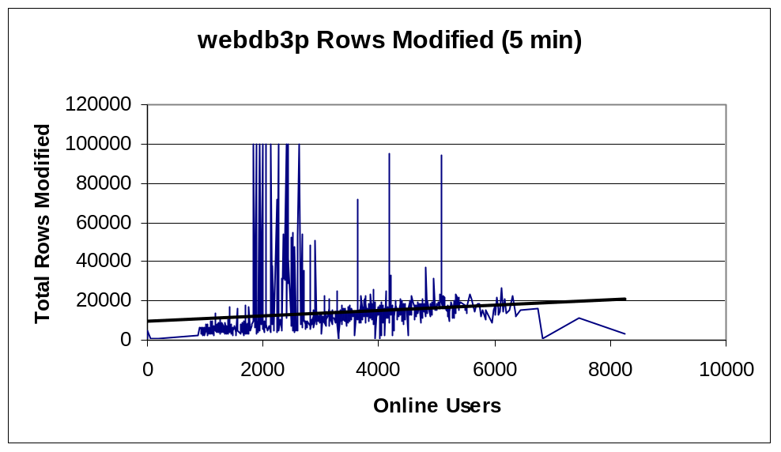

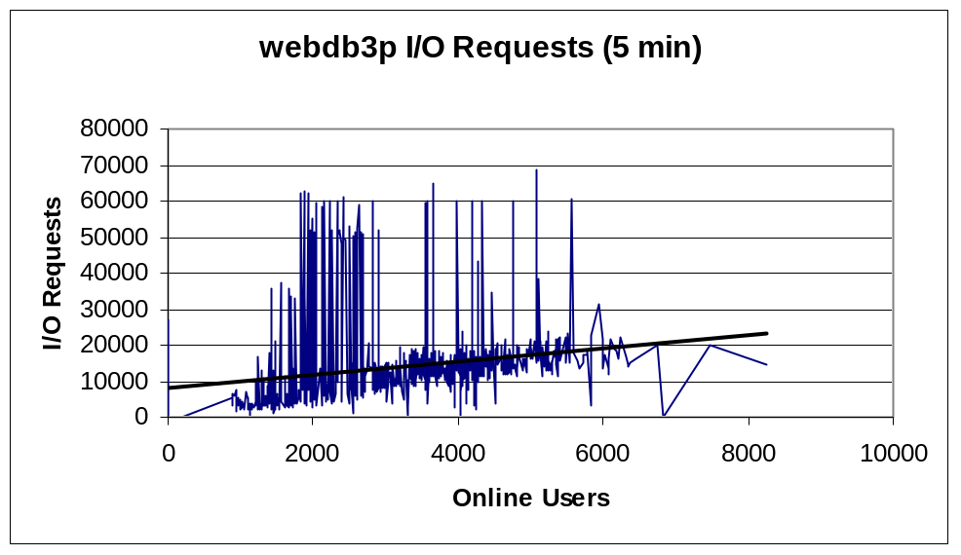

7.2.4 Webdb4p

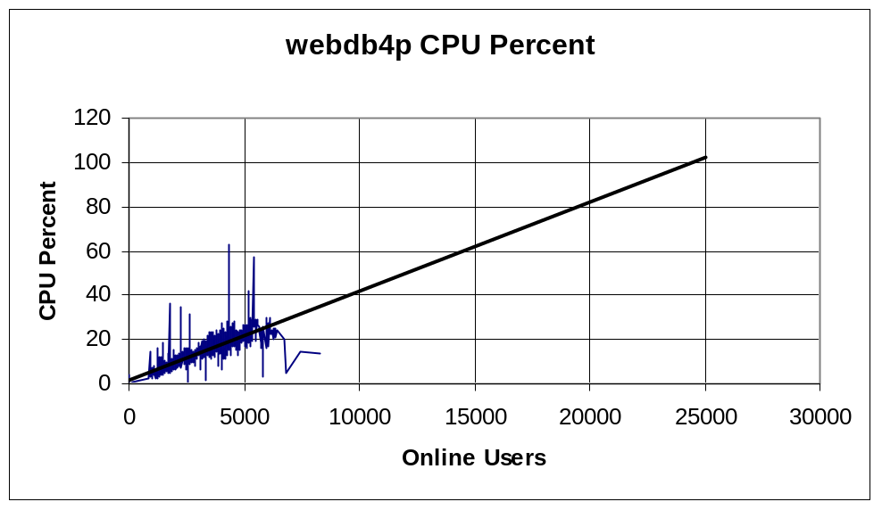

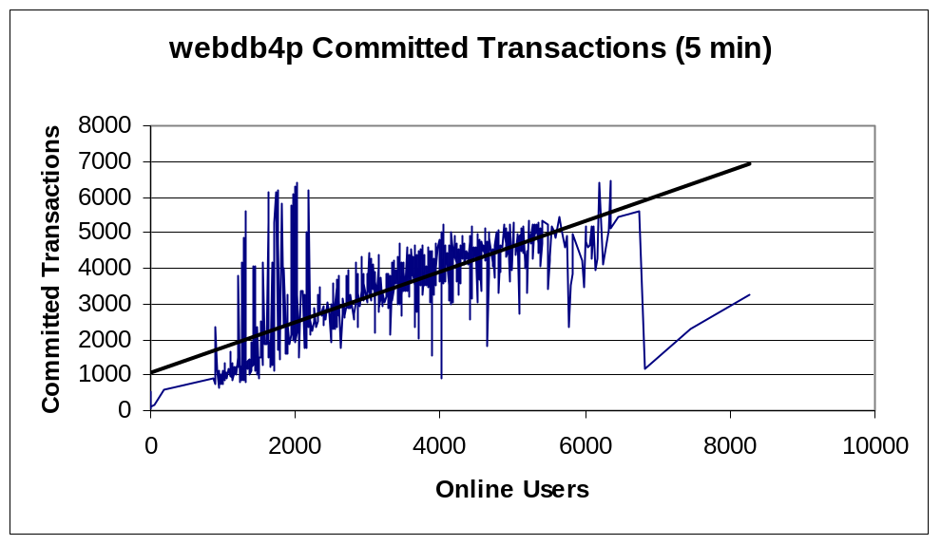

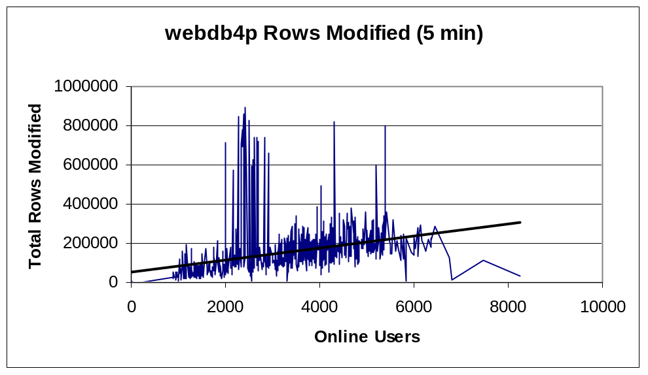

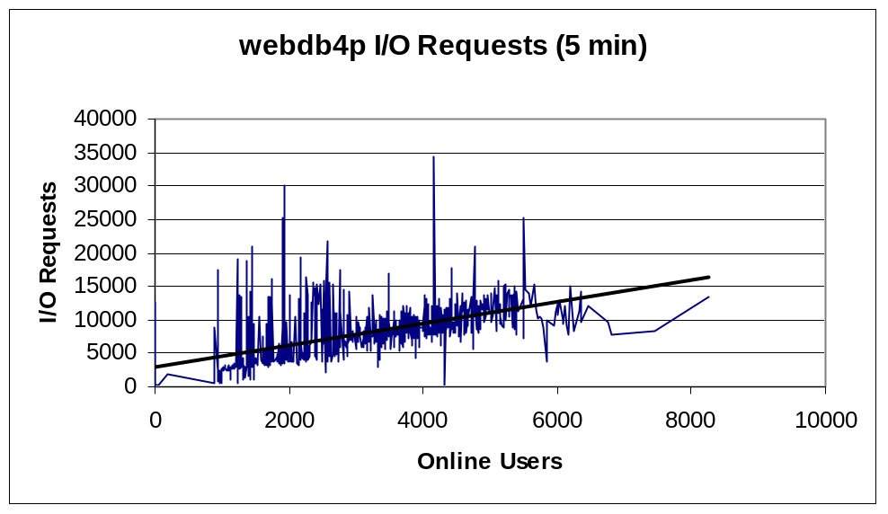

7.2.5 Webdb5p

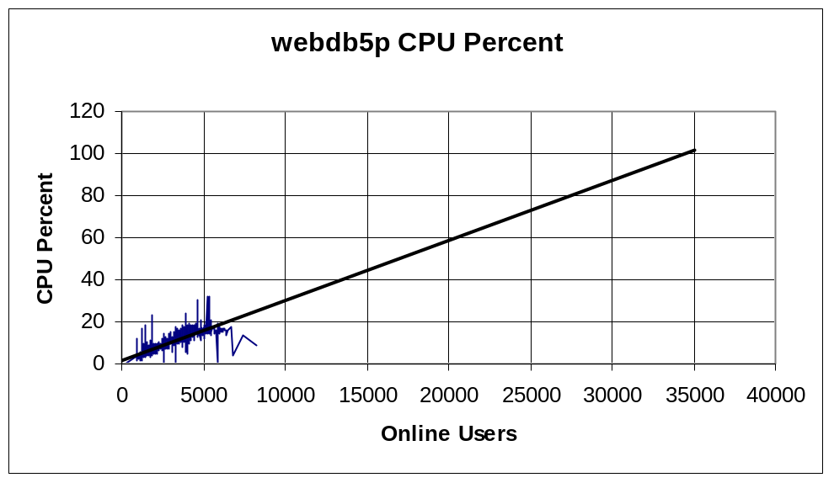

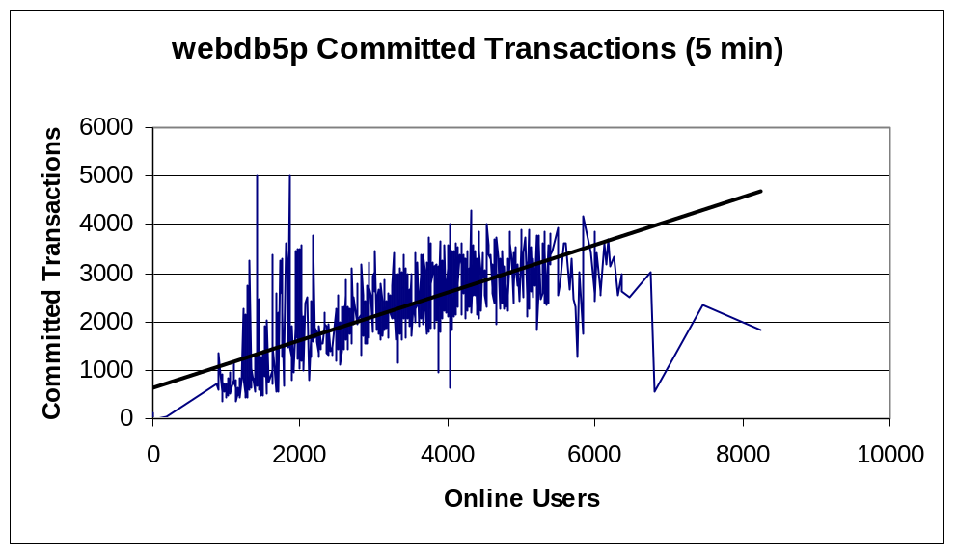

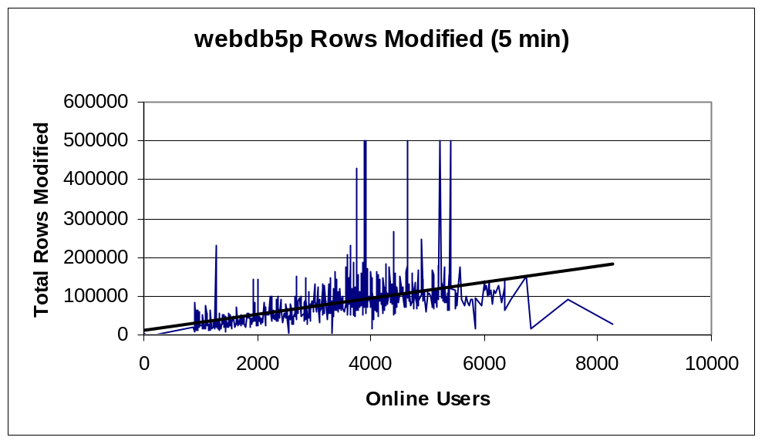

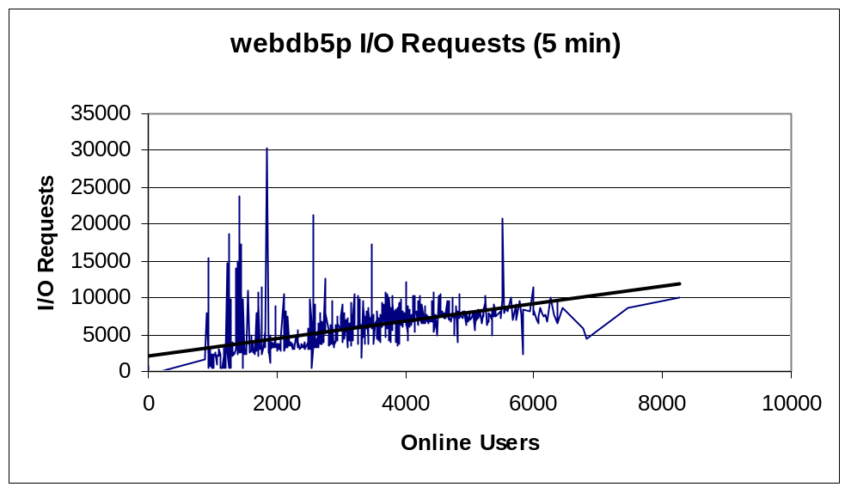

7.3 Recommendations

New features and bug fixes are added to the system on a regular basis. Each new feature has the potential to affect performance. Therefore continuous monitoring of the database servers is necessary to ensure that performance remains at an acceptable level.

Total capacity across the 5 database servers could be increased if processing was more evenly distributed. The Web Platform ‘X’ team has already identified some tables on webdb3p which could be easily moved to a less utilized server. This should also be an ongoing process.

A separate design process is currently underway to review the entire database structure. This includes database layouts, stored procedure access, and replication and other scalability options.

SSL Server

The SSL Server was set up to provide a secure area for sensitive credit card data.

Hardware configuration for the SSL Server is:

- Dual 700Mhz PIII, with 512Mb ram and 9Gb Disk.
- The operating system is Linux.

8.1 Key Indicators

This study focused on vmstat information for CPU usage, Swap Used and Blocks per second of i/o.

8.2 Results

We found a spike of CPU usage and disk i/o during the period when 1000 to 2000 concurrent users were accessing the system. Further investigation found that this was due to the 5:00am ‘log rotate’ process. The log rotate process occurs once a day. During this procedure logs greater than 1 week old are truncated and the previous day’s logs are processed and copied to the webmonitor server for reporting.

We found that CPU utilization on the SSL Server was flat as the number of users increased. A regression line on this data shows that our current SSL Server architecture can support a maximum of approximately over 1,000,000 users before performance will begin to degrade.

In addition, Swap space used remained relatively constant which indicates that there is enough RAM available to satisfy user requests. Disk i/o was also very low.

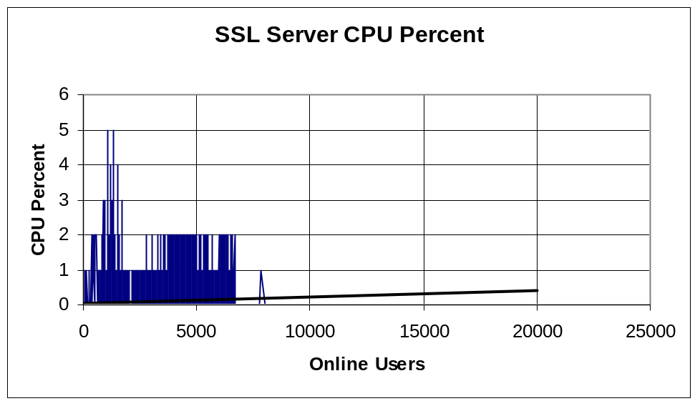

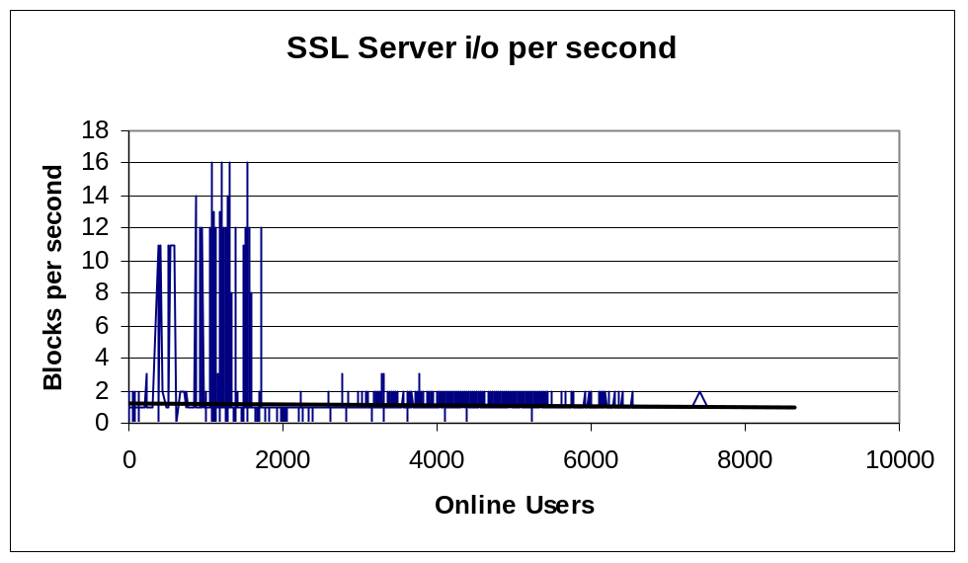

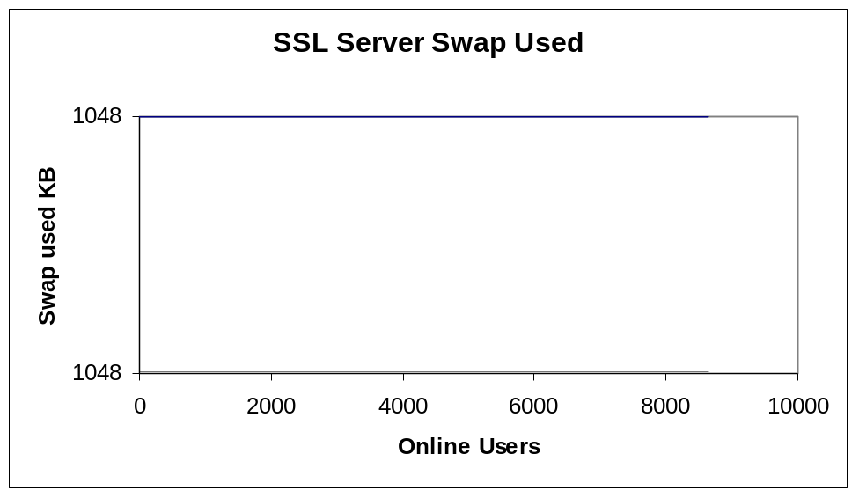

8.3 Recommendations

Although this server should be monitored on an ongoing basis, we do not currently see any issues involving performance or scalability.

Image Server

The Image Server stores and services requests for all of the user pictures in the Webpersonals system.

Hardware configuration is as follows:

- Dual 700Mhz PIII, with 512Mb ram and 43GB Disk.
- The operating system is Linux.

9.1 Key Indicators

This study focused on vmstat information for CPU usage, Swap Used and Blocks per second of i/o.

9.2 Results

We found a spike of CPU usage and disk i/o during the period when 1000 to 2000 concurrent users were accessing the system. Further investigation found that this was due to the 5:00am ‘log rotate’ process. The log rotate process occurs once a day. During this procedure logs greater than 1 week old are truncated and the previous day’s logs are processed and copied to the webmonitor server for reporting.

We found that CPU utilization on the Image Server was flat as the number of users increased. A regression line on this data shows that our current SSL Server architecture can support a maximum of over 1,000,000 users before performance will begin to degrade.

In addition, Swap space used remained relatively constant which indicates that there is enough RAM available to satisfy user requests. Disk i/o was also very low.

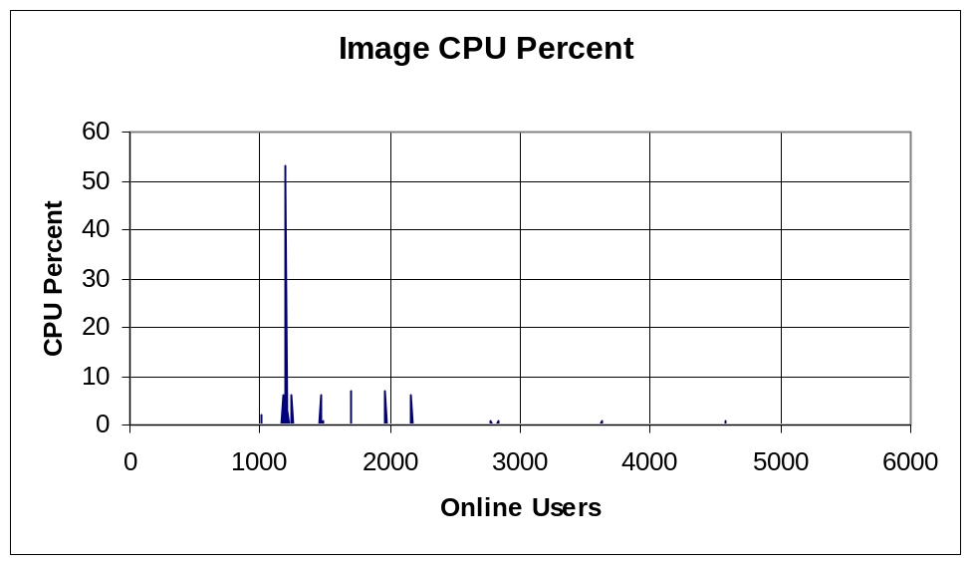

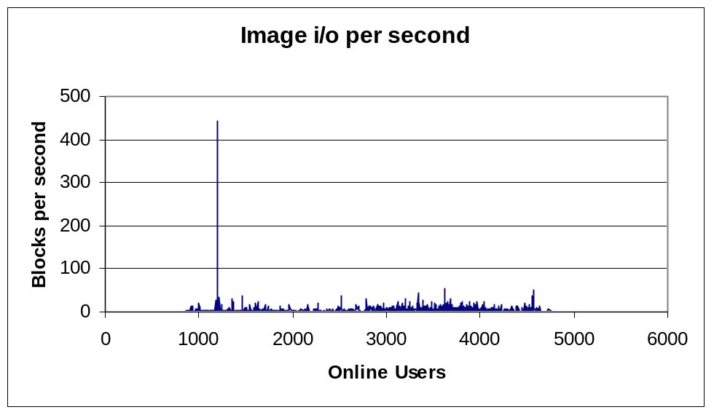

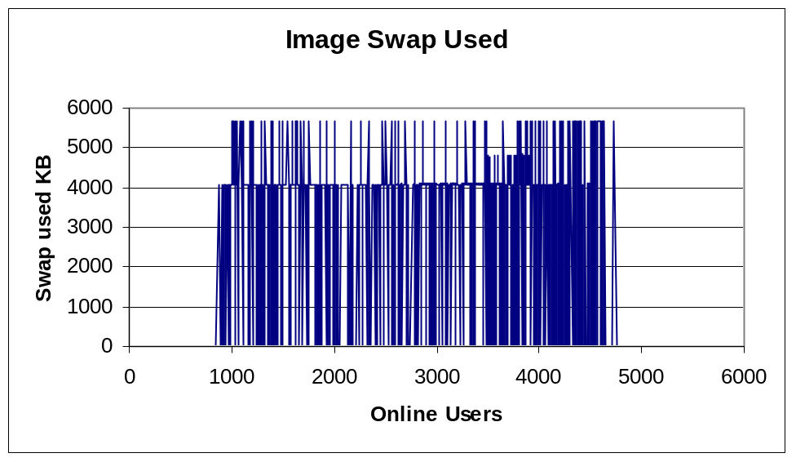

9.3 Recommendations

We do not believe that the image server will be a bottleneck, however monitoring of the server and especially disk utilization should be ongoing.

In particular, this server should be extensively reviewed after the ‘Backstage’ enhancements have been implemented which allow users to post up to 20 pictures instead of the current 1 picture.

Real Audio Server

The Real Audio Server stores user audio ad files. These are fed from the IVR on a regular basis.

Hardware configuration is as follows:

- Sun Ultra-1 (Sparc Cpu), 256Mb RAM and 20Gb Disk
- Sun O/S 5.6

10.1 Key Indicators

This study focused on vmstat information for CPU usage, Swap Used and Blocks per second of i/o.

10.2 Results

We found that all of our indicators showed very low values. No significant increase was found for either indicator as the number of online users increased.

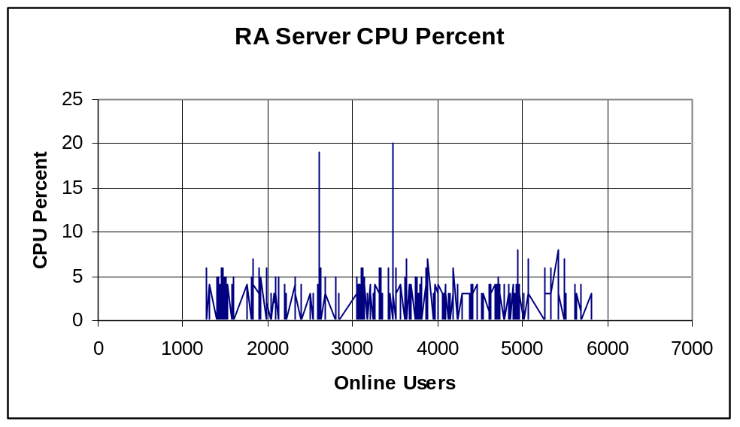

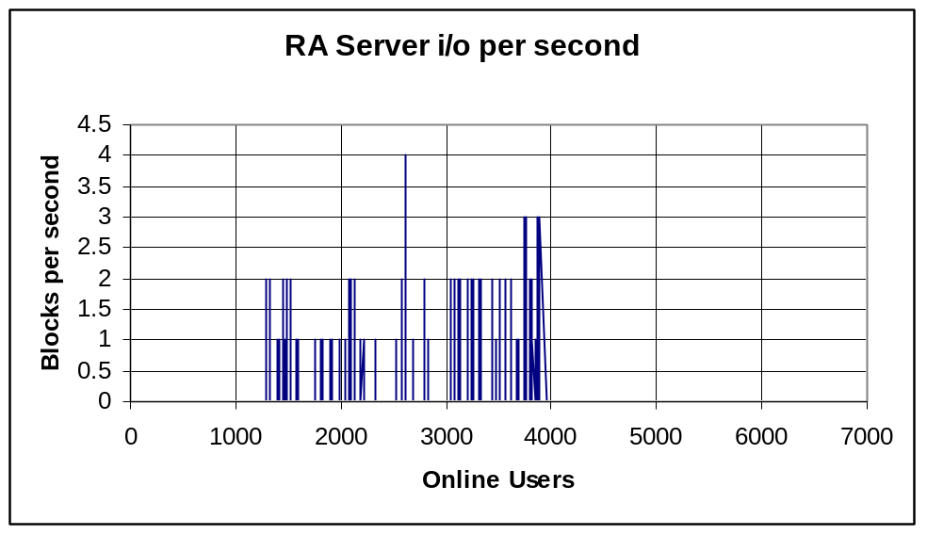

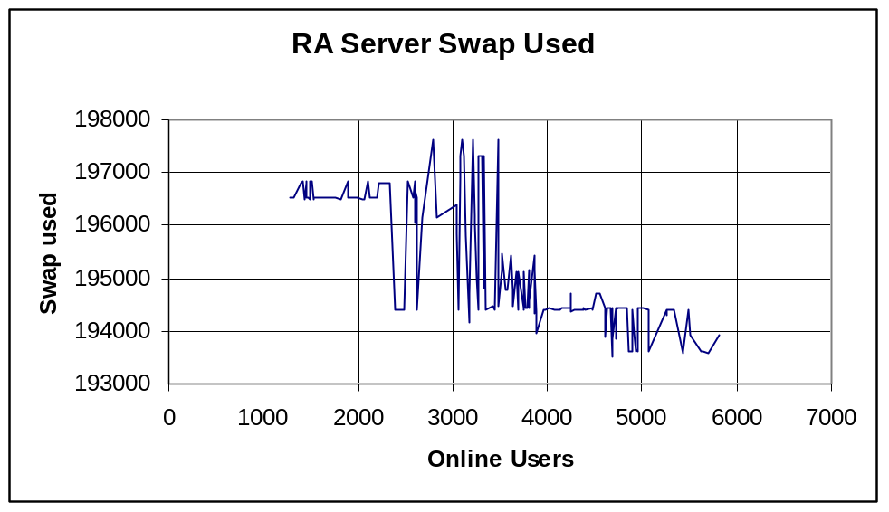

10.3 Recommendations

Monitoring of this server should be an ongoing process. However, at this time, we do not believe that the Real Audio Server will pose a bottleneck in the foreseeable future.

Summary

Capacity Summary by Component

The following table summarizes the results of our capacity estimates by component under the current version of Webpersonals 2.0.

Component | Est. Capacity | Notes
Network | 10,000 Users | 13,000 @ 45Mbits; 30,000 @ 100Mbits
Firewalls | 20,000 Users | Additional firewalls will support 6,500 users each
Web Servers | 16,000 Users | Additional servers will support 1,600 users each
Webdb1p | 13,000 Users
Webdb2p | 17,000 Users
Webdb3p | 10,000 Users | Add’l processing to be offloaded to webdb4p and 5p
Webdb4p | 24,000 Users
Webdb5p | 34,000 Users
SSL Server | > 1,000,000 Users
Image Server | > 1,000,000 Users | Limited only by disk space and network i/o
RA Server | > 1,000,000 Users | Limited only be disk space and network i/o

Summary of Recommendations

An ongoing process of monitoring all of the above components is necessary for two main reasons:

- Bug Fixes and Enhancements are being added to the system on a continuous basis which may adversely affect system performance.
- Our capacity numbers are estimations and should be verified and adjusted as the actual number of concurrent users increase.

Our findings show us that we are approaching 2 bottlenecks at approximately 10,000 concurrent users:

- Network Bandwidth
- Database Servers

We are in the process of increasing our bandwidth to the Internet. This should be implemented by the end of January 2001.

Of the database servers, our main bottleneck appears to be Webdb3p (the instant messaging server). We have identified some tables on the Webdb3p server which can be moved to a less utilized server (ie. Webdb4p or Webdb5p) with minimal changes to the code. This should help to distribute database processing more evenly. We are also reviewing the database impact of message ‘polling’ from web browsers to ensure that access to this database server is as efficient as possible.

